Maximizing Sales and optimizing Services of a Financial cum Service-Based Firm
Midterm report for the BDM capstone Project

Submitted by
Name: Debjit Mondal
Roll number: 23f2004618
Email: 23f2004618@ds.study.iitm.ac.in



IITM BS Degree Program,
Indian Institute of Technology, Madras, Chennai
Tamil Nadu, India, 600036
Contents
- Executive Summary 2
- Proof of Originality of Data 3
- Meta Data
  - Mutual fund transaction data 5
  - Historical returns of mutual funds 6
  - Quarterwise NAV data 6
  - Risk assessment form 7
- Descriptive Statistics
  - Mutual fund transaction data 7
  - Historical returns of mutual funds 8
  - Quarterwise NAV data 9
- Explanation of analytics process 9
- Results and findings 10
- Further analysis plan 12

Executive Summary
Unique Enterprise is a financial and service-based firm established in 2019, with its primary focus on mutual fund sales. Over time, the business has expanded its service portfolio to include insurance products, financial services such as income tax return (ITR) filing and money transfers, as well as air and railway ticket booking. The firm caters to a diverse customer base, offering essential financial solutions with an emphasis on transparency, reliability, and customer satisfaction.
Despite its diverse offerings, Unique Enterprise faces a few challenges. The firm is struggling to maximize profit from mutual fund sales, as earnings in this segment have not grown as expected. The business sells mutual fund schemes on an ad-hoc basis which may impact on overall growth in AUM (Asset Under Management) which led to slow growth in profits. Additionally, there are difficulties in aligning client portfolios with their individual risk profiles, leading to inconsistencies in investment strategies and affecting overall customer satisfaction. Competition like online mutual fund sales platforms offers suggestions in mutual fund sales according to the risk category which indeed cause the business loss in potential customers. Although the business collects substantial data, it has not been fully utilized to assess key metrics like profitability, customer retention, and service demand.
To overcome these challenges, the project will focus on leveraging existing data including transaction records, historical NAVs, and customer risk assessments to improve decision-making in new mutual funds sales by using tools like spreadsheets and Google Colab. This approach will enable the identification of high-performing funds and align client portfolios more accurately with their individual risk profiles. These enhancements are expected to lead to increased customer satisfaction and retention. With these improvements, Unique Enterprise will be better positioned to boost profitability, enhance client loyalty, and achieve sustainable growth in the financial services sector.

Proof of Originality of Data
  - Business Details:
    - Name of the business: Unique Enterprise
    - Owner: Indrajit Mondal
    - Address: Bahula, P.O: Bahula, Paschim Bardhaman, West Bengal, PIN: 713322
    - Google map link: https://maps.app.goo.gl/fvjKFBHPPgAVM5Ds5
    - Mobile No of owner: 8001386145/8637524520
    - Email Id of business: indrajitmondal127@gmail.com / investajbahula@gmail.com
    - Operation of mutual fund sales: By a partnering agency through their web portal
    - Present no of clients: 163
    - Commission earned from Mutual fund sales: The owner refused to share the commission earned statement due to partnering agency’s policy, however the owner stated that the business receives 0.5% per annum of total AUM as commission.


  - Photos:
Owner and Office of Unique Enterprise
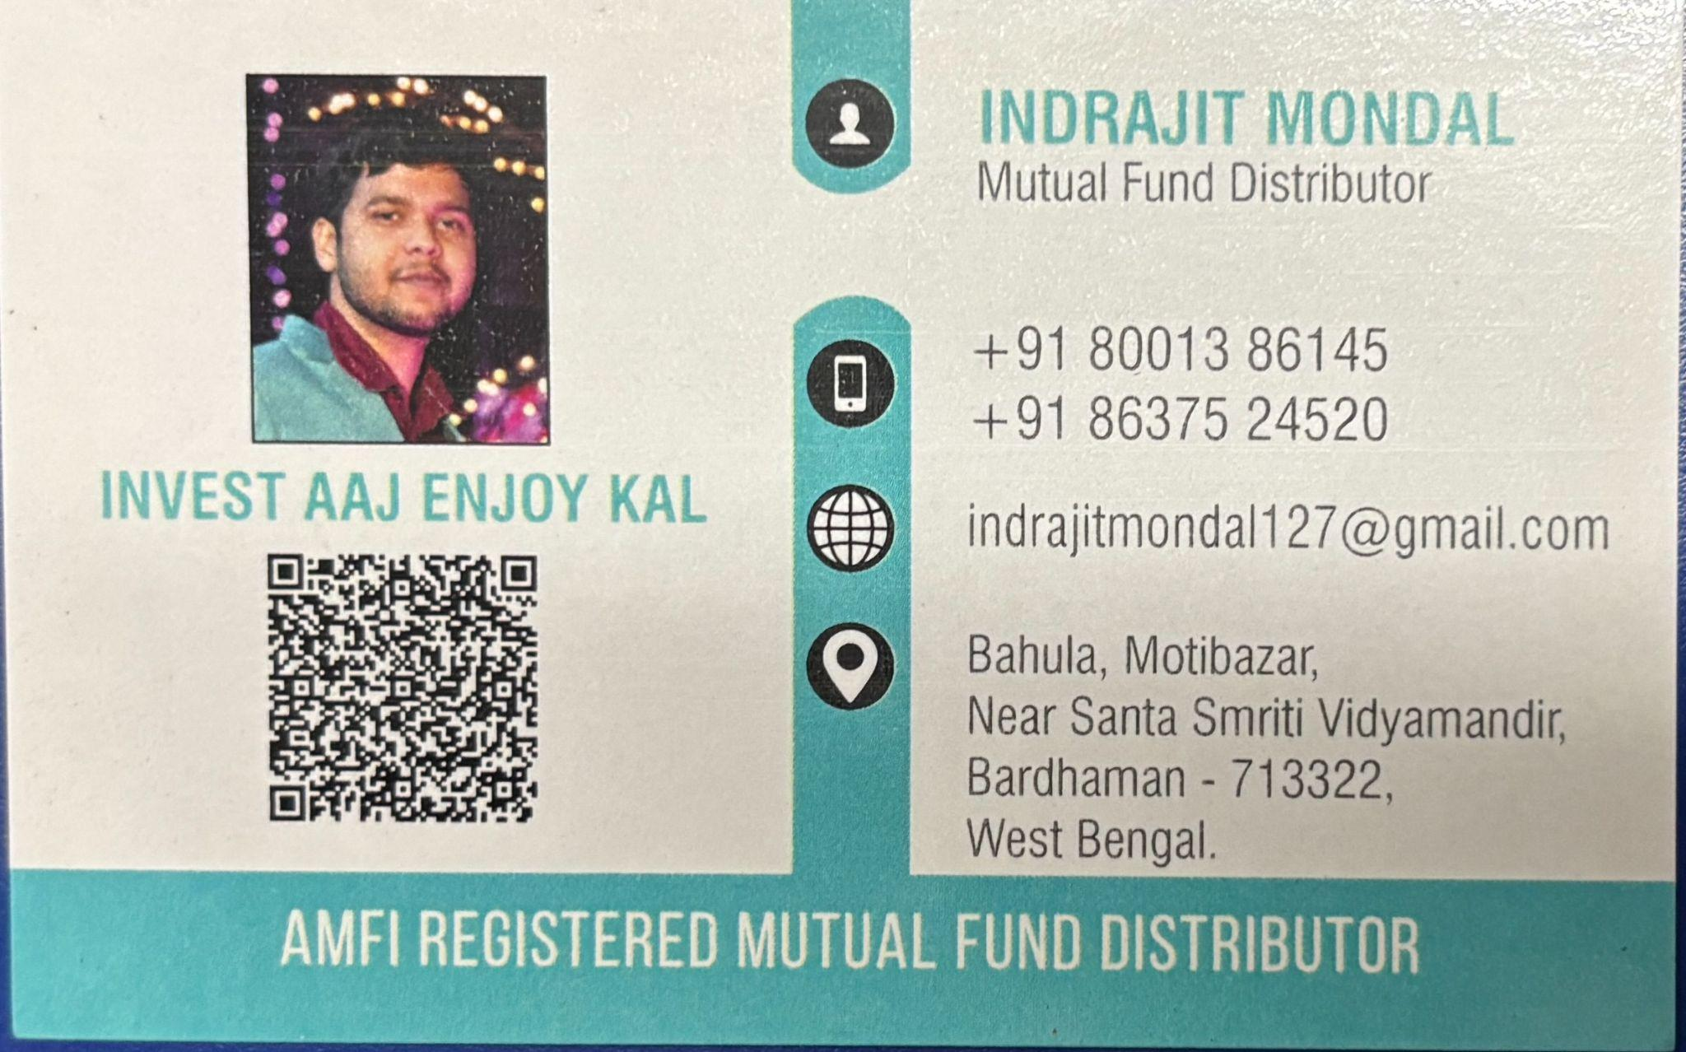
Business Card of the owner
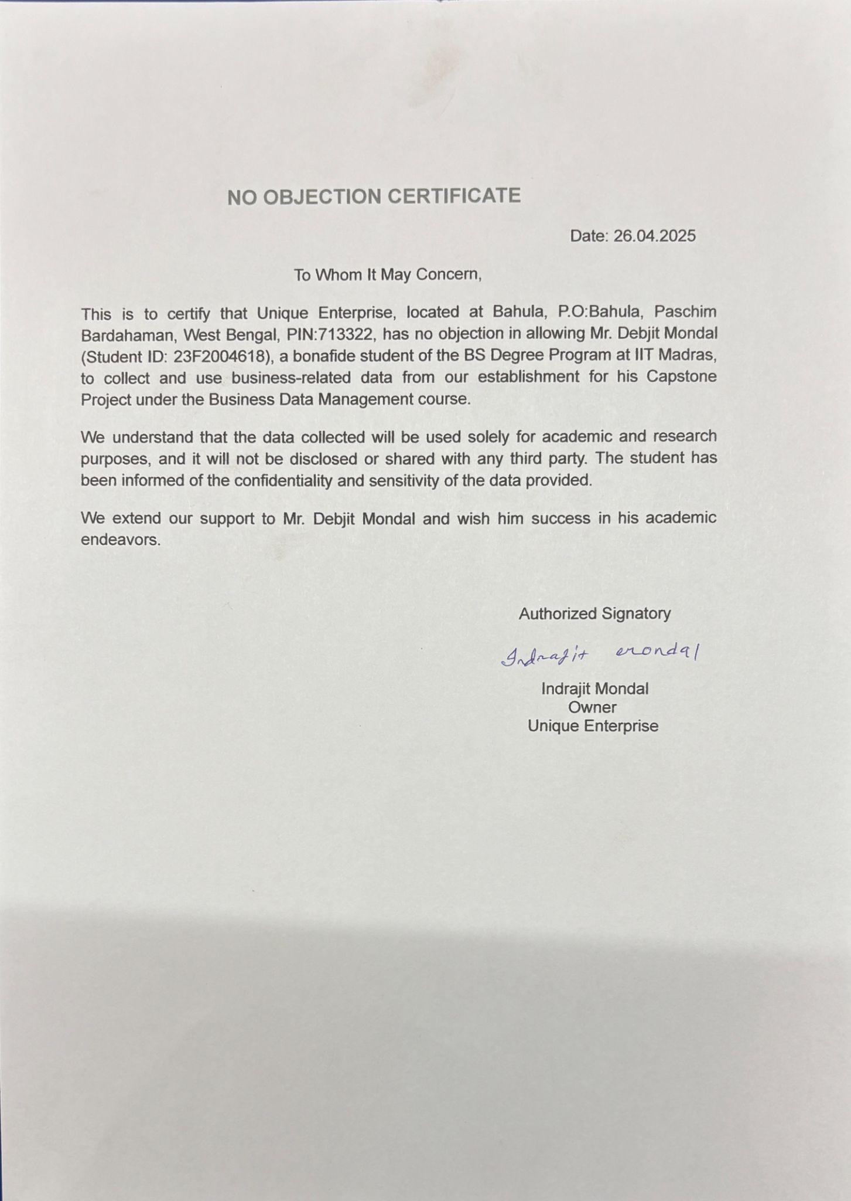
No Objection Certificate from Unique Enterprise
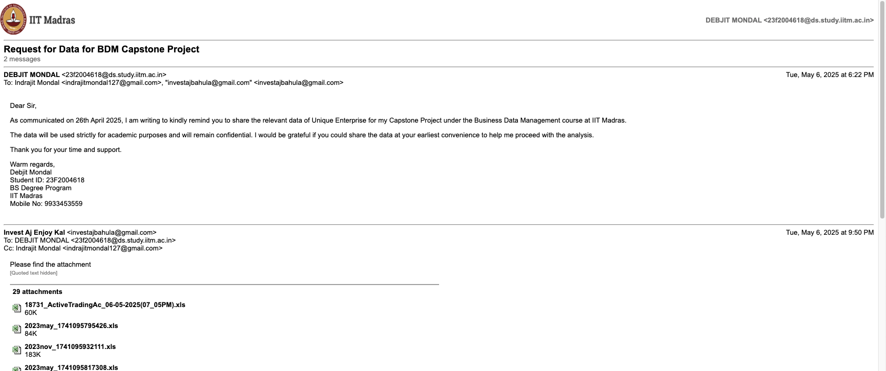
Data from Unique Enterprise
  - Interaction Video with owner:
https://drive.google.com/file/d/1qxuDkev7YJzsWWER1kD75b3hjucPMlrm/view?usp=sharing (At the business office)
https://drive.google.com/file/d/1zyLAav_2pB0JP4_SfSidu0Tq4HhYy1uV/view?usp=drive_link (Doubt discussion regarding business with the owner) (Note: As the owner is out of station for a few days using google meet. Due to non availability of recording function in google meet, using inbuilt recorder of pc and therefore no audio of the other person is recorded)
  - Drive link for photos, videos and email (pdf):
https://drive.google.com/drive/folders/1sZa46KCoMv-6xQbrbY0VoYzp7k5LkAal?usp=drive_link
  - Drive link for raw data sent by Unique Enterprise:
https://drive.google.com/drive/folders/1gn_29tHUCDGZeclAys0WFE611qamgmVb?usp=sharing
  - Risk assessment form for Unique Enterprise (Survey link):
https://docs.google.com/forms/d/e/1FAIpQLSdKv2isTiOg5-EHrDzbSmVjnnHA83W6i9IzILSzNtcnxmjNfw/viewform?usp=sharing

Meta Data
  - Mutual fund Transaction data:
    - Format: .xlsx
    - No of files: 2 (Two)
    - Data range: March-2022 to February-2025
      - Purchase sheet (New investment data)
        - No of records: 5365
        - Shape of the dataset: 5367x15

Purchase sheet (New investment)

      - Redemption data
        - No of records: 261
        - Shape of the dataset: 263x14

Redemption sheet

    - Column details:
      - Sr. No: Serial Number (Type: Number)
      - Trxn Mode: Mode of the transaction (Type: Text)
      - Partner/Employee: Name of the partner/employee (Type: Text)
      - Group: Name of the group (Type: Text)
      - Investor: Name of the investor (Type: Text)
      - Type: Type of the transaction, PIP: Lumpsum investment, PIP(SIP): Systematic investment etc. (Type: Text)
      - Purchase date: Date of new investment (Type:Date)
      - Redemption date: Date of redeeming from investment (Type:Date)
      - Folio No/ Demat No: Portfolio or demat A/C number (Type: Number)
      - Scheme: Name of the Scheme of the new investment (Type: Text)
      - ISIN: ISIN number of the Scheme (Type: Number)
      - NAV: Per unit price of the Scheme on that date. (Type: Number)
      - Purchase units: No of unit purchased (Type: Number)
      - No of units: No of units redeemed (Type: Number)
      - Amount: Amount that invested/ redeem in the scheme (Type: Number)
      - Balance unit: Balance unit of the investor in that scheme (Type: Number)
      - Post date: When the data updated in the record (Type: Date)

  - Historical Return of Mutual funds data:
    - Format: .xlxs
    - No of files: 3 (Three) (after data cleaning processed in 1 file)
    - No of records: 1208
    - Shape of the dataset: 1209x9

Historical return data

    - Column details:
      - Scheme/ Benchmark: Name of the scheme (Type: Text)
      - 6M : Return for 6 month period (Type: Percent(%))
      - 1y: Return for 1 year period (Type: Percent(%))
      - 5y: Return for 5 years period (Type: Percent(%))
      - 10y: Return for 10 years period (Type: Percent(%))
      - 15y: Return for 15 years period (Type: Percent(%))
      - Inception Date: Date of inception of the scheme (Type: Date)
      - Expense Ratio(%): Expense percentage deducted of investment if redeem (Type: Percent(%))

  - Quarterwise NAV data:
    - Format: .docx (converted to .xlxs after processing)
    - No of files: 13 (Thirteen) (compiled in 1 file after processing)
    - No of records: 90889
    - Data range: March-2022 to March-2025 (quarterly)
    - Shape of the dataset: 90890 x 8

Quarterwise NAV sheet

    - Columns:
      - Scheme Code: Type of the scheme (Type: Text)
      - Scheme Name: Name of the scheme (Type: Text)
      - ISIN Div Payout/ ISIN Growth: ISIN no of the scheme (Type: Number)
      - ISIN Div Reinvestment: ISIN no of the scheme (Type: Number)
      - Net Asset Value: Per unit price of the Scheme on that date. (Type: Number)
      - Date: Date of the NAV of the scheme (Type: Date)

  - Risk assessment form responses:
    - Format: Via Google-form (Form containing questions), hard copy of form also given to the business for use, if any response received via hard copy of form, it will be proceed to google spreadsheet
    - No of records: 15(Fifteen) (Till 02.06.2025)
Risk assessment form response sheet

    - Form response sheet
      - Columns: Contains different answers of questions regarding financial investment
    - Score sheet:
      - Columns: Score as per answers in form response sheet
      - Formula used to calculate risk assessment score (pdf): Prepared with discussion with the business owner: https://drive.google.com/file/d/1jk9qblpoVV_owNsLwX8ts--c7DsvYwWG/view?usp=sharing

Descriptive Statistics:
  - Mutual fund Transaction data:
    - New Investment data:

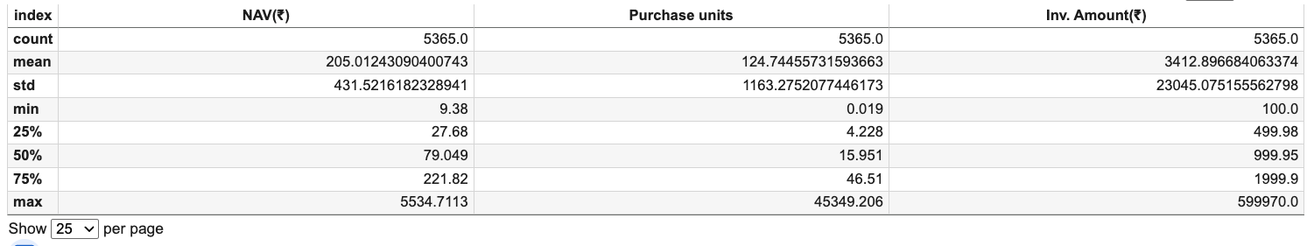New Investment data statistics
The average Net Asset Value (NAV) of all schemes sold by the business is ₹205.01 with a standard deviation of ₹431.52. The NAV ranges from a minimum of ₹9.38 to a maximum of ₹5,534.71.
The average number of units sold per transaction is 124.74 with a standard deviation of 1,163.28 units. The number of units sold per transaction ranges from 0.019 to 45,349.206 units.
On average, the amount added to Assets Under Management (AUM) per transaction is ₹3,412.89 with a standard deviation of ₹23,045.07. The minimum and maximum amounts in a transaction are ₹100 and ₹599,970 respectively.

    - Redemption data:
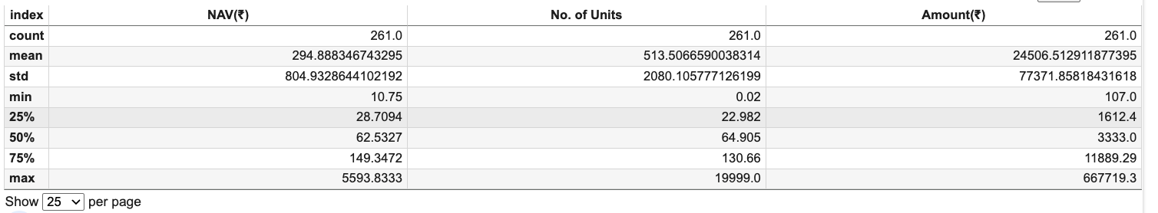
Redemption data statistics
The average Net Asset Value (NAV) of all schemes redeemed by the investor is ₹294.88 with a standard deviation of ₹804.93. The NAV ranges from a minimum of ₹10.75 to a maximum of ₹5,593.83.
The average number of units redeemed per transaction is 513.50 with a standard deviation of 2,080.10 units. The number of units redeemed per transaction ranges from 0.02 to 19,999 units.
On average, the amount deducted from Assets Under Management (AUM) per transaction is ₹24,506.51 with a standard deviation of ₹77,371.85. The minimum and maximum amounts redeemed per transaction are ₹107 and ₹667,719.30 respectively.
Although the average amount per redemption transaction is higher than that of new investments, the frequency of redemptions is significantly lower than purchases. As a result, the overall AUM continues to grow.
  - Historical Return of Mutual funds:
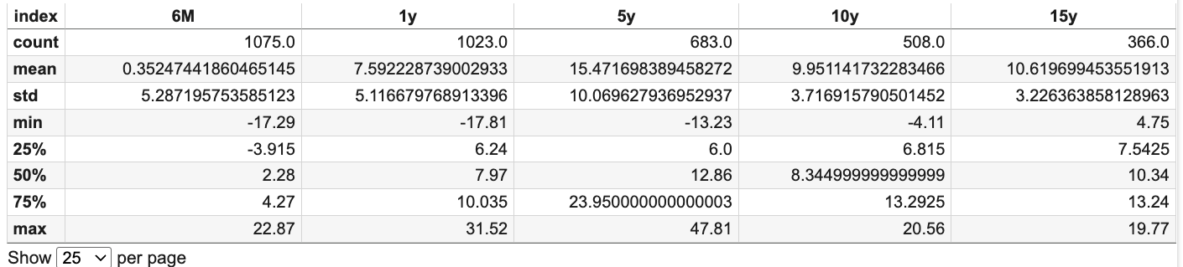
Historical return of mutual fund statistics
The average returns of all mutual funds are as follows: 0.35% over 6 months, 7.59% over 1 year, 15.47% over 5 years, 9.95% over 10 years, and 10.61% over 15 years.

  - Quarterwise NAV data:
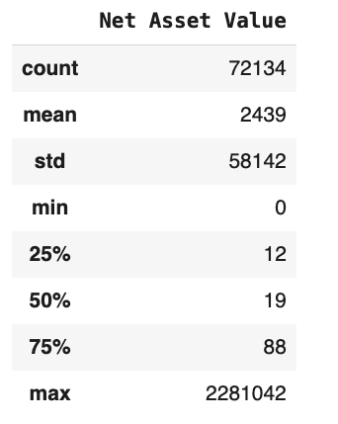
Quarterwise NAV data statistics

The average NAV of all schemes during the period from Q2-2022 to Q1-2025 is ₹2,439 with most of the NAV is over 75 percentile.

Explanation of Analysis Process
  - Using Excel, transaction records were categorized by quarter and further classified by investment type such as lump sum investments and Systematic Investment Plans (SIPs) to derive detailed insights on new investments and redemptions. This breakdown offers valuable insights like investment type (Lump Sum or SIP) preferred by the investors, repeated investment in mutual fund sales over time.

  - Historical NAV data, provided by Unique Enterprise, are in DOCX format. For further analysis; it is converted to XLSX format and consolidated into a single Excel file. By aligning this with transaction data, the quarter-wise AUM was calculated for the period from Q2 2022 to Q1 2025. This data offers valuable insights into AUM trends of the business over time.

  - To estimate the current Assets Under Management (AUM), units held by the business were calculated (as of February 28, 2025 the date of the latest available transaction), and the NAV prices for each scheme were taken from the Q1 2025 NAV data. It is assumed that no transactions occurred between February 28, 2025 and March 31, 2025 as there is no transaction record found after February 28, 2025 and NAV price of February 28, 2025 is not available on the data shared by the business.

  - Risk assessment is essential in mutual fund investments, as these involve a possibility of loss. It measures how much loss a client is willing and able to handle in their investments or financial decisions, in exchange for potential gains. New investors often lack a clear understanding of their risk capacity, making risk assessment a crucial first step in the investment process. For existing clients, regular reassessment is important, as their financial situations, investment goals may change over time. Competition like online mutual fund selling platforms gives the options to choose mutual funds according to the risk category. It causes potential loss of clients for the business. To address the issue a risk assessment form was created and responses were collected through Google Forms and printed versions (manually updated in the response sheet). Point values were assigned to each response based on a predefined scoring, in consultation with the owner.
G-form link:
https://docs.google.com/forms/d/e/1FAIpQLSdKv2isTiOg5-EHrDzbSmVjnnHA83W6i9IzILSzNtcnxmjNfw/viewform?usp=sharing
Formula used to calculate risk assessment score (pdf):
https://drive.google.com/file/d/1jk9qblpoVV_owNsLwX8ts--c7DsvYwWG/view?usp=sharing(Prepared with discussion with the business owner)

  - Using the total risk scores, clients were categorized into different risk categories, each reflecting their individual risk profiles. This will help the business to suggest new investments to the clients aligning to their risk capacity.

  - Descriptive statistics were generated using Google Colab with the help of libraries such as pandas and scikit-learn. Data visualization and chart plotting were performed using built-in Excel functions. It helps to visualize the span of the data for further analysis.

Results and finding:
  - Mutual fund sales type:
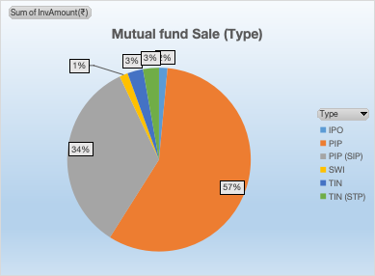
Here, IPO refers to investments made in New Fund Offerings (NFOs), PIP denotes lump sum investments, and PIP (SIP) represents investments made through a Systematic Investment Plan (SIP). It is observed that approximately 57% of new investments in terms of amount were made through lump sum (PIP) investments, while around 34% were made via Systematic Investment Plans (PIP-SIP).
  - New investment trend (sales)
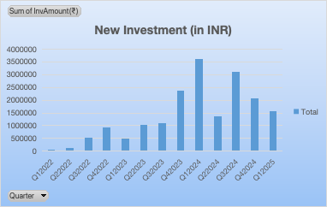
The chart shows an overall growing trend in new mutual fund investments, reaching a peak in Q1-2024 with approx. 35 lakhs of new sales. However, there is a noticeable and sudden decline in Q2-2024.

  - Redemption trend
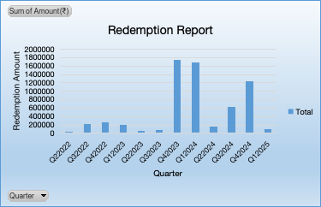
The chart indicates that redemption by the investors peaked during Q4-2023 and Q1-2024, with another noticeable increase observed in Q4-2024. Most of the time redemption of mutual funds in a quarter is below 4 lakhs.
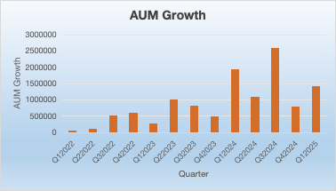
  - Asset Under Management trend
The chart shows that during Q3-2024, the growth in Assets Under Management (AUM) peaked at over ₹25 lakhs. For most other quarters, the growth typically ranged between ₹5 lakhs and ₹10 lakhs.

  - Risk Category from Risk assessment:
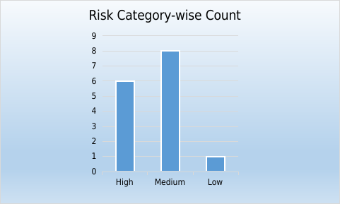
The chart shows out of 15 responses received from the risk assessment survey, eight responses fall under the medium risk category, six are in the high risk category and one is in the low risk category. More response is expected till the month end. This will help the business to suggest new investment plans to their clients. Existing client profiles can also be restructured according to their risk appetite with the help of the risk category.

Further analysis plan:
In the next phase of the analysis, mutual funds will be clustered using K-means algorithm on Google Colab, based on their return volatility using the historical return data, which reflects the risk level of each fund. This will help categorize the funds into distinct risk groups. At the same time, each client’s current risk profile, determined through the risk assessment form, will be used to match them with the most appropriate mutual fund schemes. This dual approach will ensure that clients are invested in funds that align with both their risk tolerance and financial goals. Additionally, high-return investments in different timeframes will be identified by analyzing the historical return on mutual fund trends over time which will help the business in suggesting new investment intelligently to their clients. By observing historical trends and using analytical data through linear programming, top funds will be identified across different timeframes and risk categories, which may help enhance sales strategies and lead to an increase in profits from mutual fund sales.

